HEMA Ireland Risk Assessment Template

Group: |  | Venue
Date Submitted:
Period covered:
First Aiders present:
First Aid Kit present:

Brief Description of Activities Covered by this Risk Assessment

Copy submitted to HEMA Ireland: | _________________________________________________________
Signed by Club Representative: | _________________________________________________________
Date: | _________________________________________________________

Activity |  |  |  | Comments
Risks | Unmitigated Risk |  |  | Mitigation | Mitigated Risk |  |  | Comments
 | Sev | Prob | Risk |  | Sev | Prob | Risk
General Exercise

Activity |  |  |  | Comments
Risks | Unmitigated Risk |  |  | Mitigation | Mitigated Risk |  |  | Comments
 | Sev | Prob | Risk |  | Sev | Prob | Risk

Risk Values calculated using matrix below. Find the appropriate value for the severity and probability, and add them.

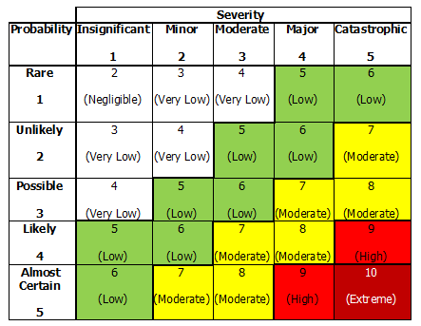

I have been made aware of the above risk assessment
Name | Date | Name | Date
[Repeat page as necessary]

